**Exercise: Playbooks - Start At**

1. Verify that your ansible installation is available by displaying the version of ansible while logged in as the 'user' user.

[test@tcox3 ~]$ ansible --version

ansible 1.9.2

  configured module search path = None

2. Run the ansible command that lists all of the hosts configured in your control server 'hosts' file for the system.

[test@tcox3 ~]$ ansible all --list-hosts

    tcox5.mylabserver.com

    localhost

    tcox4.mylabserver.com

3. Create a playbook, using the 'START AT' concepts from the video:

- Uses SSH

- Logs in to the remote system as 'test' user

- Connects to one server or group from Step #2 above

- The playbook runs as 'sudo'

- Skip gathering remote facts

- Uses three separate, named, tasks to install three packages (your choice)

--- # START AT PLAYBOOK EXAMPLE

- hosts: apacheweb

  user: test

  sudo: yes

  connection: ssh

  gather_facts: no

  tasks:

  - name: Install Telnet

    yum: pkg=telnet state=latest

  - name: Install Lynx

    yum: pkg=lynx state=latest

  - name: Install at

    yum: pkg=at state=latest

4. Run the playbook, starting with the SECOND named task and display the results.

[test@tcox3 Playbooks]$ ansible-playbook startat.yml --start-at="Install Lynx"

PLAY [apacheweb] **************************************************************

TASK: [Install Lynx] **********************************************************

changed: [tcox4.mylabserver.com]

TASK: [Install at] ************************************************************

changed: [tcox4.mylabserver.com]

PLAY RECAP ********************************************************************

tcox4.mylabserver.com      : ok=2    changed=2    unreachable=0    failed=0

So we could see it install only lynx .it s kindly of alternative of tag

Or other method - -step

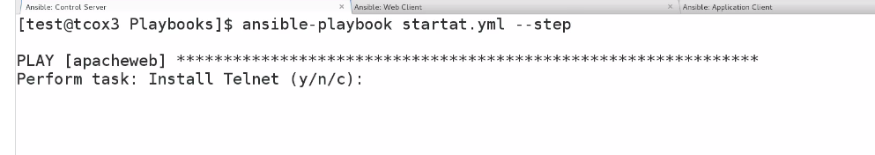

It will ask everytime before performing any task

